

DEPARTMENT OF COMPUTER ENGINEERING

**ACADEMIC YEAR 2024-2025**

**FALL/SPRING SEMESTER**

NAME OF THE COURSE

**Course Supervisor:**

Title. Name Surname

UNDERGRADUATION THESIS/PROJECT/HOMEWORK TITLE

**Prepared by:**

Name Surname

**Student No:**

1111111111111

**ACKNOWLEDGMENTS**

I would like to express my deepest gratitude to my esteemed advisor, Prof. Dr. ___ ___, for her invaluable support and guidance throughout my undergraduate studies and the preparation of this thesis.

I am also profoundly thankful to my co-advisor, Prof. Dr. ___ ___, for his generous contributions and insightful advice during my research.

My heartfelt appreciation goes to my beloved family and colleagues for their unwavering encouragement and assistance throughout this work.

This thesis was supported by the Scientific Research Project of Düzce University under project number SRP-XXX-WWW.

**28 May 2025 Name Surname**

TABLE OF CONTENTS

**Page No**

LIST OF FIGURES Vii

CHART LIST VIII

MAP LIST Ix

ABBREVIATIONS x

ICONS Xi

SUMMARY XII

ABSTRACT Xiii

1. ENTRANCE 1

2. MATERIALS AND METHODS (THIS TITLE IS NOT MANDATORY) 2

2.1. SUBHEADING 1 5

2.1.1. Subheading 2 5

2.1.2. Subheading 2 5

2.1.2.1. Subheading 3 5

2.1.2.2. Subheading 3 6

2.1.3. Footnotes 7

2.2. SUBHEADING 1 7

3. CHAPTER 3 9

3.1. SUBHEADING 1 10

3.1.1. Subheading 2 10

3.1.1.1. Subheading 3 10

3.1.1.2. Subheading 3 10

3.2. SUBHEADING 1 10

3.2.1. Subheading 2 10

4. CHAPTER 4 12

4.1. SUBHEADING 1 12

4.1.1. Subheading 2 12

4.1.1.1. Subheading 3 12

4.1.1.2. Subheading 3 12

4.2. SUBHEADING 1 13

5. RESULTS AND DISCUSSION 14

5.1. SUBHEADING 1 14

5.1.1. Subheading 2 14

5.2. SUBHEADING 1 14

5.2.1. Subheading 2 14

5.2.1.1. Subheading 3 14

6. WRITING OF REFERENCES 15

6.1. METHOD OF ADDING RESOURCES 15

7. RESULTS AND DISCUSSION 16

7.1. SAMPLE SOURCE LIST FOR NUMERICAL REFERENCE TECHNIQUE 16

7.2. SAMPLE SOURCE LIST FOR HARVARD REFERENCE TECHNIQUE 17

8. CONCLUSIONS AND RECOMMENDATIONS 21

9. RESOURCES 22

10. ECLAIR 23

10.1. APPENDIX 1: TITLE NAME 23

10.2. APPENDIX 2: TITLE NAME 26

10.3. APPENDIX 3: TITLE NAME 29

RESUME 31

LIST OF FIGURES

**Page No**

Figure 2.1. View 1. 3

Figure 2.2. View 1. 3

Figure 2.3. Landscape 2. 4

Figure 2.4. View 3 a) Istanbul b) Eminönü c) Galata bridge. 6

Figure 2.5. When the figure number changes, it will automatically change in the paragraph.) To update the automatic changes, simply click the print preview ( ) icon. 6

Figure 2.6. Landscape 2. 6

Figure 2.7. View 4. 7

Figure 2.8. Landscape 2. 7

Figure 3.1. View 5. 9

Figure 3.2. View 5. 11

Figure 3.3. View 5. 11

Figure 4.1. View 5. 12

Figure 4.2. View 5. 13

Figure 10.1. View 5. 23

Figure 10.2. View 5. 24

Figure 10.3. View 5. 25

Figure 10.4. View 5. 26

Figure 10.5. View 5. 27

Figure 10.6. View 5. 27

Figure 10.7. View 5. 29

Figure 10.8. View 5. 30

Figure 10.9. View 5. 30

TABLE LIST

**Page No**

Table 2.1. Units1. 3

Table 2.2. Units 1. 3

Table 2.3. Units 2. 8

Table 3.1. Units 3. 10

Table 4.1. Units 4. 13

Table 5.1. Units 5. 14

Table 5.2. Units 6. 14

Table 10.1. Units 3. 24

Table 10.2. Units 3. 27

Table 10.3. Units 3. 30

MAP LIST

**Page No**

Map 2.1. Solar map of Turkey1. 4

Map 2.2. Solar map of Turkey1. 8

Map 3.1. Map 2. 10

Map 3.2. Map 2. 11

Map 4.1. Map 3. 13

Map 10.1. Map 2. 24

Map 10.2. Map 2. 25

Map 10.3. Map 2. 26

Map 10.4. Map 2. 28

Map 10.5. Map 2. 29

ABBREVIATIONS

|  |  |  |
| --- | --- | --- |
| Aco |  | Acetate |
| ABS |  | Acrylonitrile/butadiene/styrene |
| BBP |  | Benzyl butyl phthalate |
| DEGA |  | Diethylengglycol adipate |
| DOP |  | Dioctyl phthalate |
|  |  |  |
|  |  |  |
|  |  |  |
|  |  |  |
|  |  |  |
|  |  |  |
|  |  |  |
|  |  |  |
|  |  |  |
|  |  |  |
|  |  |  |
|  |  |  |
|  |  |  |
|  |  |  |
|  |  |  |
|  |  |  |
|  |  |  |
|  |  |  |
|  |  |  |

Symbols

|  |  |  |
| --- | --- | --- |
| G |  | Conductivity |
| P |  | Power (for electric current) |
| S |  | Siemens |
| σ |  | Self-Conductivity |
| Ω |  | Ohm |
|  |  |  |
|  |  |  |
|  |  |  |
|  |  |  |
|  |  |  |
|  |  |  |
|  |  |  |
|  |  |  |
|  |  |  |
|  |  |  |
|  |  |  |
|  |  |  |
|  |  |  |
|  |  |  |
|  |  |  |
|  |  |  |
|  |  |  |
|  |  |  |
|  |  |  |

ABSTRACT

**THE TITLE OF THE THESIS SHOULD BE WRITTEN HERE IN ENGLISH**

Student Name SURNAME

Düzce University

Faculty of Engineering, Computer Engineering

Undergraduate Thesis

Supervisor: Title. Name SURNAME

September 2019, 30 pages

Here, the English abstract of the thesis should be written as one paragraph. Here, the English abstract of the thesis should be written as one paragraph. Here, the English abstract of the thesis should be written as one paragraph. Try not to exceed 1 page.

**Keywords:** Keyword one, Keyword two, Keyword three.

# INTRODUCTION

This THESIS TEMPLATE has been created according to the thesis writing rules. For detailed information, see the thesis writing guide.

(INTRODUCTION REQUIRED).

The Introduction Section of the Thesis is the part where the Literature Summary related to the Thesis, the Purpose of the Thesis and the Contribution to the Literature are mentioned.

# MATERIALS AND METHODS (THIS TITLE IS NOT MANDATORY)

Chapter 1 was the Introduction to the Thesis. Chapter 2 and later contain the chapter headings and subheadings in the content of the thesis. It can be done as many times as desired. (THIS TITLE IS NOT MANDATORY).

Below is the writing and automatic numbering of the Figures, Charts and Equations to be used in the thesis in connection with the figure in the paragraph. In this template, each equation, chart and figure numbers are automatically progressed.

Figure references are given before figures. Figure 2.1 It is automatically numbered. This can be copied and reproduced as many times as desired. In a paragraph *add-cross-reference-Figure* If the Figure is referenced by selecting it, the Figure number will change as it changes in the paragraph (To update the changes only, click PREVIEW PRINT ()) icon.) Otherwise, the numbers may not be updated.

NOTE: IF THE PRINT PREVIEW DOESN'T APPEAR, YOU CAN ADD IT FROM THE QUICK ACCESS TOOLBAR BELOW.

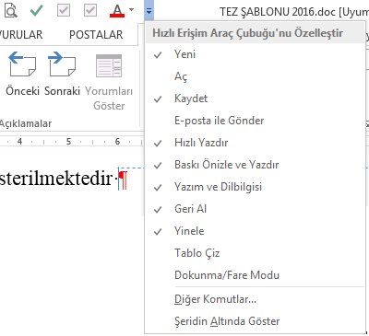

Paragraph.

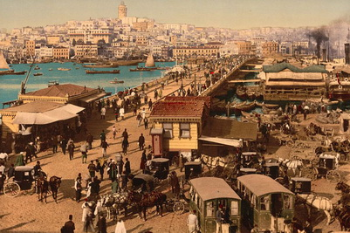

Figure 2.1. View 1.



Figure 2.2. View 1.

Table 2.1 It is automatically numbered.

Table 2.1. Units1.

|  |  |  |  |
| --- | --- | --- | --- |
| Unit System | Mass (m) | Acceleration (a) | Force (F) |
| SI | Kg | m/s2 | kg m/s2 (N) |
| Cgs | g | cm/s2 | G cm/s2 (dyn) |

Table 2.2. Units 1.

|  |  |  |  |
| --- | --- | --- | --- |
| Unit System | Mass (m) | Acceleration (a) | Force (F) |
| SI | Kg | m/s2 | kg m/s2 (N) |
| Cgs | g | cm/s2 | G cm/s2 (dyn) |

There should be 1.5 lines of spacing between the text before the figure and the figure.



Figure 2.3. Landscape 2.

Paragraph.

|  |  |  |  |
| --- | --- | --- | --- |
| Unit System | Mass (m) | Acceleration (a) | Force (F) |
| SI | Kg | m/s2 | kg m/s2 (N) |
| Cgs | g | cm/s2 | G cm/s2 (dyn) |

Map 2.1 It shows the solar map of Turkey.

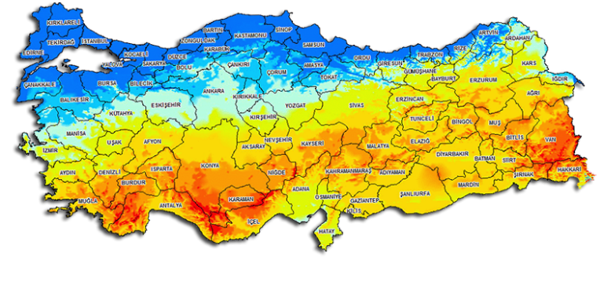

Map 2.1. Solar map of Turkey1.

Paragraph.

## SUBHEADING 1

Paragraph.

|  |  |
| --- | --- |
|  | (2.1) |
|  | (2.2) |

Equation (2.2) It is automatically numbered. In a paragraph *insert-cross-reference-equation* If the equation is referenced by selecting it, as the equation number changes, it will also change in the paragraph (To update the changes only, click PRINT PREVIEW () icon. Otherwise, the numbers may not be updated.

**NOTE**: IF THE PRINT PREVIEW DOESN'T APPEAR, YOU CAN ADD IT FROM THE QUICK ACCESS TOOLBAR BELOW.



Paragraph.

### Subheading 2

Paragraph.

### Subheading 2

Paragraph.

#### Subheading 3

Paragraph.

#### Subheading 3

Paragraph.

If there is more than one figure in a single figure text, it is named as a, b and written under the figure, and the explanation of a, b is also included in the figure text.

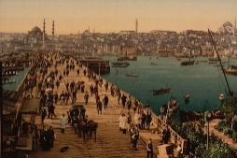  

a) b) c)

Figure 2.4. View 3 a) Istanbul b) Eminönü c) Galata bridge.



Figure 2.5. When the figure number changes, it will automatically change in the paragraph.) To update the automatic changes, simply click the print preview ( ) icon.

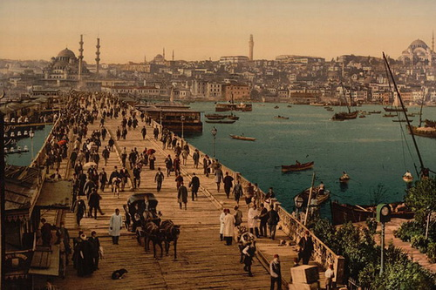

Figure 2.6. Landscape 2.

Paragraph.

### Footnotes

Some explanations needed in the text can be given at the bottom of the page in the form of footnotes. Footnotes should be short and concise so as not to distract from the subject and attention. Footnotes are written in 8-10 font size and 1 line spacing. This rule applies to all pages that use more than one footnote.[1] The footnote is added from the references menu.

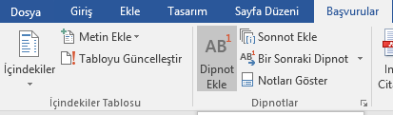

## SUBHEADING 1

Paragraph.



Figure 2.7. View 4.



Figure 2.8. Landscape 2.

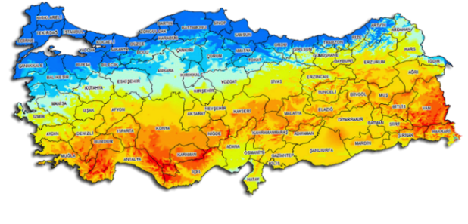

Map 2.2. Solar map of Turkey1.

Table 2.3. Units 2.

|  |  |  |  |
| --- | --- | --- | --- |
| Unit System | Mass (m) | Acceleration (a) | Force (F) |
| SI | Kg | m/s2 | kg m/s2 (N) |
| Cgs | g | cm/s2 | G cm/s2 (dyn) |

# CHAPTER 3

Chapter 1 was the Introduction to the Thesis. Chapter 2 and later contain the chapter headings and subheadings in the content of the thesis. It can be done as many times as desired.

Paragraph.

|  |  |
| --- | --- |
|  | (3.1) |
|  | (3.2) |

Paragraph.

|  |  |
| --- | --- |
|  | (3.3) |

Equation (3.2) All equations are numbered automatically. In a paragraph *insert-cross-reference-equation* If the equation is referenced by selecting it, as the equation number changes, the one in the paragraph will also change.



Figure 3.1. View 5.

Paragraph.

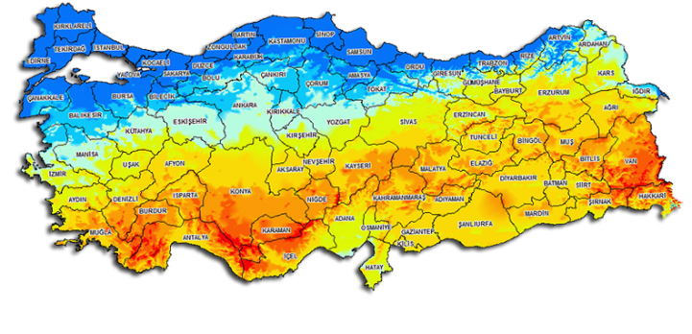

Map 3.1. Map 2.

## SUBHEADING 1

Paragraph.

### Subheading 2

Paragraph.

#### Subheading 3

Paragraph.

#### Subheading 3

Paragraph.

Table 3.1. Units 3.

|  |  |  |  |
| --- | --- | --- | --- |
|  |  |  |  |
| Unit System | Mass (m) | Acceleration (a) | Force (F) |
| SI | Kg | m/s2 | kg m/s2 (N) |
| Cgs | g | cm/s2 | G cm/s2 (dyn) |
|  |  |  |  |

Paragraph.

## SUBHEADING 1

Paragraph.

### Subheading 2

Paragraph.



Figure 3.2. View 5.



Figure 3.3. View 5.

Paragraph.



Map 3.2. Map 2.

# CHAPTER 4

Chapter 1 was the Introduction to the Thesis. Chapter 2 and later contain the chapter headings and subheadings in the content of the thesis. It can be done as many times as desired.

Paragraph.

## SUBHEADING 1

Paragraph.

### Subheading 2

Paragraph.

#### Subheading 3

Paragraph.

#### Subheading 3

Paragraph.



Figure 4.1. View 5.

Paragraph.

## SUBHEADING 1



Figure 4.2. View 5.

Paragraph.



Map 4.1. Map 3.

Paragraph.

Table 4.1. Units 4.

|  |  |  |  |
| --- | --- | --- | --- |
|  |  |  |  |
| Unit System | Mass (m) | Acceleration (a) | Force (F) |
| SI | Kg | m/s2 | kg m/s2 (N) |
| Cgs | g | cm/s2 | G cm/s2 (dyn) |

Paragraph.

# RESULTS AND DISCUSSION

In this section, the findings and discussion can be written. (THIS TITLE IS NOT MANDATORY).

Table 5.1. Units 5.

|  |  |
| --- | --- |
| Rs |  |
|  |  |

Paragraph.

## SUBHEADING 1

Paragraph.

### Subheading 2

Paragraph.

## SUBHEADING 1

### Subheading 2

Paragraph.

#### Subheading 3

Paragraph.

Table 5.2. Units 6.

|  |  |
| --- | --- |
| Rs |  |
|  |  |

Paragraph.

# WRITING OF REFERENCES

The original of the research cited in the research should be in the hands of the researcher. The number of references used should be reasonable, directly related to the thesis topic and up-to-date. However, when it is very necessary, old, classical sources should be used. Published papers, abstracts, publications in print can be used as references. Unpublished reports, lecture notes, and personal opinions may be included in the list of references. Web pages can be used as resources; However, the addresses of the web pages used should be included in the list of resources with the access date.

In showing the sources in the text, reference indication with numbers should be used.

## METHOD OF ADDING RESOURCES

Numerical Reference Technique (Numerical Reference Number) or Harvard Reference Technique (Surname Year notation) should be used to show the sources in the text. FOR ***THE RULES OF REFERENCE CITATION AND CREATING A LIST, PLEASE REVIEW THE REFERENCES SECTION OF THE THESIS WRITING GUIDE IN DETAIL. IN ADDITION, THERE IS A DETAILED EXPLANATION OF THE MENDELEY PROGRAM AND VIDEO LINKS IN THE THESIS WRITING GUIDE.***

It is recommended to install and use the Mendeley program to add source references. The Mendeley program automatically creates its own references section. The numbers given here are automatically generated with this program. It is not manually typed [1]. When the references are added in the text as follows, the references will be numbered automatically [2]–[4] and will be arranged [1], [2], [5], [6].

# RESULTS AND DISCUSSION

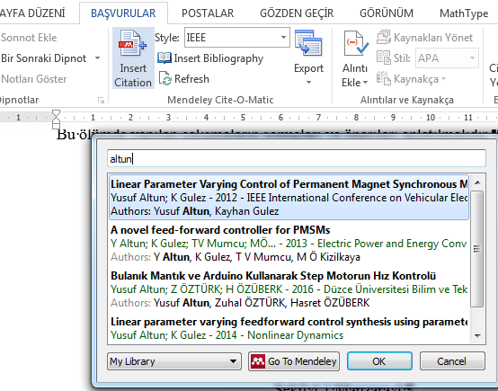

WHEN ADDING A LIST OF REFERENCES TO THE LATEST RESOURCES SECTION, YOU CAN ADD IT AUTOMATICALLY (BY CLICKING INSERT BIBLIOGRAPHY) AS FOLLOWS.

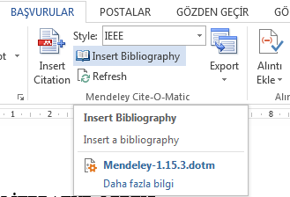

NOTE: THESE RESOURCES ARE CREATED AUTOMATICALLY WITHOUT WRITING WITH THE MENDELEY PROGRAM.

**A detailed description** of the MENDELEY program is available **in Appendix 9 of the THESIS WRITING GUIDE**.

## SAMPLE SOURCE LIST FOR NUMERICAL REFERENCE TECHNIQUE

The list of references is numbered according to the order given in the thesis and arranged as follows. In thesis written in Turkish, words such as the name of the work, authors, and proper names, volume, *number, page order (ss) and/or their abbreviations are used in Turkish, number instead of vol. c. no. and ss. instead of pp.* In thesis written in English, all expressions should be in English.

For this**, it is recommended to install and use** the Mendeley program. A detailed description of **the Mendeley** program is available in Appendix 9 of the Thesis Writing Guide. *IEEE must be selected as the style source in the Mendeley program, and Turkish must be selected from the language settings in theses written in Turkish.*

The Mendeley program automatically creates its own references section. It automatically sorts and creates the citations and reference list in the thesis. There is no need for manual typing.

[1] G. Pipeleers, B. Demeulenaere, J. Swevers, and L. Vandenberghe, "Systems & Control Letters Extended LMI characterizations for stability and performance of linear systems", Systems & Control Letters, vol. 58, no. 7, pp. 11-12. 510–518, 2009.

[2] B. Lu, F. Wu, and S. W. Kim, "Switching LPV control of an F-16 aircraft via controller state reset", IEEE Transactions on Control Systems Technology, vol. 14, no. 2, pp. 267–277, 2006.

[3] V. Q. Leu, H. H. Choi, and J. W. Jung, "Fuzzy sliding mode speed controller for PM synchronous motors with a load torque observer", IEEE Transactions on Power Electronics, vol. 27, no. 3, pp. 11-12. 1530–1539, 2012.

[4] M. Alma, J. J. Martinez, I. D. Landau, and G. Buche, "Design and tuning of reduced order H-infinity feedforward compensators for active vibration control", IEEE Transactions on Control Systems Technology, vol. 20, no. 2, pp. 554–561, 2012.

[5] K. Graichen, M. Treuer, and M. Zeitz, "Swing-up of the double pendulum on a cart by feedforward and feedback control with experimental validation", Automatica, vol. 43, no. 1, pp. 1-1. 63–71, 2007.

[6] X. Litrico, V. Fromion, and G. Scorletti, "Robust feedforward boundary control of hyperbolic conservation laws", Proceedings of the 45th IEEE Conference on Decision and Control, pp. 11-12. 5311–5316, 2006.

[7] I. Masubuchi and I. Kurata, "Gain-scheduled control via filtered scheduling parameters", Automatica, vol. 47, no. 8, pp. 1821–1826, 2011.

## SAMPLE SOURCE LIST FOR HARVARD REFERENCE TECHNIQUE

Reference references should be added in Harvard Reference Citation standards. *When writing the conference and book reference list, the page order "(ss. 102-125)".*

In thesis written in Turkish, words such as the name of the work, authors, and proper names, volume, *number, page order (ss) and/or their abbreviations are used in Turkish, number instead of vol. c. no. and ss. instead of pp.* In thesis written in English, all expressions should be in English.

For this**, it is recommended to install and use** the Mendeley program. A detailed description of **the Mendeley** program is available in Appendix 9 of the Thesis Writing Guide. *In the Mendeley program, Harvard Educational Review should be selected as the style source, and Turkish must be selected from the language settings for theses written in Turkish.*

The Mendeley program automatically creates its own references section. It automatically sorts and creates the citations and reference list in the thesis. There is no need for manual typing.

Agharkakli, A., Sabet, G., & Barouz, A. (2012). Simulation and analysis of passive and active suspension system using quarter car model for different road profile. *International Journal of Engineering Trends and Technology*, *3*(5), 636–644.

Altun, Y. (2017). The road disturbance attenuation for quarter car active suspension system via a new static two-degree-of-freedom design. *An International Journal of Optimization and Control: Theories & Applications (IJOCTA)*, *7*(2), 142–148.

Altun, Y., Erol, O., & Aktaş, M. (2017). Simulation and Analysis of Hydraulic-Pneumatic Quadruple Tank System. In *International Conference on Hydraulics, Pneumatics, Tools, Sealing Elements, Fine Mechanics, Specific Electronic Equipment & Mechatronics– HERVEX 2017* (pp. 281–286). Băile Govora, Romania.

Chowdhury, D., Chattopadhyay, M., Roy, P., Lynch, K. M., Marchuk, N., Elwin, M. L., ... Manikandan, B. V. (2015). Speed control of Brushless DC motor using bat algorithm optimized Adaptive Neuro-Fuzzy Inference System. *Embedded Computing and Mechatronics with the PIC32*, *32*, 279–285.

Feng, Y., & Yagoubi, M. (2017). Dilated Linear Matrix Inequalities. In *Robust Control of Linear Descriptor Systems* (pp. 23–43). Springer.

Lauwerys, C., Swevers, J., & Sas, P. (2005). Robust linear control of an active suspension on a quarter car test-rig. *Control Engineering Practice*, *13*(5), 577–586.

Roy, P., & Krishna Roy, B. (2015). Fractional order PI control applied to level control in coupled two tank MIMO system with experimental validation. *Control Engineering Practice*. https://doi.org/10.1016/j.conengprac.2016.01.002

Sinthipsomboon, K., Hunsacharoonroj, I., Khedari, J., Pongaen, W., & Pratumsuwan, P. (2011). A hybrid of fuzzy and fuzzy self-tuning PID controller for servo electro-hydraulic system. In *Proceedings of the 2011 6th IEEE Conference on Industrial Electronics and Applications, ICIEA 2011* (pp. 220–225).

Wang, K., He, P., Tang, J., & Chen, J. (2018). Static output feedback H∞ control for active suspension system with input delay and parameter uncertainty. *Advances in Mechanical Engineering*, *10*(7), 1687814018786581.

Zhao, P., & Nagamune, R. (2018). Discrete-Time State-Feedback Switching LPV Control with Separate Lyapunov Functions for Stability and Local Performance. In *2018 Annual American Control Conference (ACC)* (pp. 2023–2028).

Zheng, J. ming, Zhao, S. dun, & Wei, S. guo. (2009). Application of self-tuning fuzzy PID controller for a SRM direct drive volume control hydraulic press. *Control Engineering Practice*, *17*(12), 1398–1404.

**Article Example:**

Agharkakli, A., Sabet, G., & Barouz, A. (2012). Simulation and analysis of passive and active suspension system using quarter car model for different road profile. *International Journal of Engineering Trends and Technology*, *3*(5), 636–644.

Zheng, J. ming, Zhao, S. dun, & Wei, S. guo. (2009). Application of self-tuning fuzzy PID controller for a SRM direct drive volume control hydraulic press. *Control Engineering Practice*, *17*(12), 1398–1404.

**Conference Sample:**

Altun, Y., Erol, O., & Aktaş, M. (2017). Simulation and Analysis of Hydraulic-Pneumatic Quadruple Tank System. In International *Conference on Hydraulics, Pneumatics, Tools, Sealing Elements, Fine Mechanics, Specific Electronic Equipment &*

Sinthipsomboon, K., Hunsacharoonroj, I., Khedari, J., Pongaen, W., & Pratumsuwan, P. (2011). A hybrid of fuzzy and fuzzy self-tuning PID controller for servo electro-hydraulic system. In *Proceedings of the 2011 6th IEEE Conference on Industrial Electronics and Applications, ICIEA 2011* (pp. 220–225).

Zhao, P., & Nagamune, R. (2018). Discrete-Time State-Feedback Switching LPV Control with Separate Lyapunov Functions for Stability and Local Performance. In *2018 Annual American Control Conference (ACC)* (pp. 2023–2028).

**Book Sample:**

Feng, Y., & Yagoubi, M. (2017). Dilated Linear Matrix Inequalities. In *Robust Control of Linear Descriptor Systems* (pp. 23–43). Springer.

# CONCLUSIONS AND RECOMMENDATIONS

(THE CONCLUSION SECTION IS MANDATORY).

The conclusion(s) reached in the light of the information obtained *should be written in a clear, short and understandable style*, the extent to which the purpose of the research has been realized; If the researcher has a suggestion, it should be stated. The recommendations to be made should be directly related to the purpose and results of the research. *Figures and charts are not included in this section*.

# RESOURCES

[1] B. Lu, F. Wu, and S. W. Kim, "Switching LPV control of an F-16 aircraft via controller state reset", *IEEE Transactions on Control Systems Technology*, Vol. 14, No. 2, pp. 267–277, 2006.

[2] V. Q. Leu, H. H. Choi, and J. W. Jung, "Fuzzy sliding mode speed controller for PM synchronous motors with a load torque observer", *IEEE Transactions on Power Electronics*, Vol. 27, No. 3, pp. 1530–1539, 2012.

[3] M. Alma, J. J. Martinez, I. D. Landau, and G. Buche, "Design and tuning of reduced order H-infinity feedforward compensators for active vibration control", *IEEE Transactions on Control Systems Technology*, Vol. 20, No. 2, pp. 554–561, 2012.

[4] K. Graichen, M. Treuer, and M. Zeitz, "Swing-up of the double pendulum on a cart by feedforward and feedback control with experimental validation", *Automatica*, Vol. 43, No. 1, pp. 63–71, 2007.

[5] X. Litrico, V. Fromion, and G. Scorletti, "Robust feedforward boundary control of hyperbolic conservation laws", *Proceedings of the 45th IEEE Conference on Decision and Control*Ss. 5311–5316, 2006.

[6] I. Masubuchi and I. Kurata, "Gain-scheduled control via filtered scheduling parameters", *Automatica*, Vol. 47, No. 8, pp. 1821–1826, 2011.

# ECLAIR

## APPENDIX 1: TITLE NAME

This section is the part where the Appendices, if any, are located. Headings should be as they are here. It is automatically numbered only when you copy and duplicate it. All equations can be copied and duplicated in the same way as figures, charts, etc.

Paragraph.

|  |  |
| --- | --- |
|  | (10.1) |
|  | (10.2) |

Paragraph.

|  |  |
| --- | --- |
|  | (10.3) |

Paragraph.



Figure 10.1. View 5.

Paragraph.



Map 10.1. Map 2.

Paragraph.

Table 10.1. Units 3.

|  |  |  |  |
| --- | --- | --- | --- |
|  |  |  |  |
| Unit System | Mass (m) | Acceleration (a) | Force (F) |
| SI | Kg | m/s2 | kg m/s2 (N) |
| Cgs | g | cm/s2 | G cm/s2 (dyn) |
|  |  |  |  |

Paragraph.



Figure 10.2. View 5.



Figure 10.3. View 5.

Paragraph.



Map 10.2. Map 2.

## APPENDIX 2: TITLE NAME

This section is the part where the Appendices, if any, are located. Headings should be as they are here. It is automatically numbered only when you copy and duplicate it. All equations can be copied and duplicated in the same way as figures, charts, etc.

Paragraph.

|  |  |
| --- | --- |
|  | (10.4) |
|  | (10.5) |

Paragraph.

|  |  |
| --- | --- |
|  | (10.6) |

Paragraph.



Figure 10.4. View 5.

Paragraph.



Map 10.3. Map 2.

Paragraph.

Table 10.2. Units 3.

|  |  |  |  |
| --- | --- | --- | --- |
|  |  |  |  |
| Unit System | Mass (m) | Acceleration (a) | Force (F) |
| SI | Kg | m/s2 | kg m/s2 (N) |
| Cgs | g | cm/s2 | G cm/s2 (dyn) |
|  |  |  |  |

Paragraph.



Figure 10.5. View 5.



Figure 10.6. View 5.

Paragraph.



Map 10.4. Map 2.

## APPENDIX 3: TITLE NAME

This section is the part where the Appendices, if any, are located. Headings should be as they are here. It is automatically numbered only when you copy and duplicate it. All equations can be copied and duplicated in the same way as figures, charts, etc.

Paragraph.

|  |  |
| --- | --- |
|  | (10.7) |
|  | (10.8) |

Paragraph.

|  |  |
| --- | --- |
|  | (10.9) |

Paragraph.



Figure 10.7. View 5.

Paragraph.



Map 10.5. Map 2.

Paragraph.

Table 10.3. Units 3.

|  |  |  |  |
| --- | --- | --- | --- |
|  |  |  |  |
| Unit System | Mass (m) | Acceleration (a) | Force (F) |
| SI | Kg | m/s2 | kg m/s2 (N) |
| Cgs | g | cm/s2 | G cm/s2 (dyn) |
|  |  |  |  |

Paragraph.



Figure 10.8. View 5.



Figure 10.9. View 5.

Paragraph.

# RESUME

**PERSONAL INFORMATION**

|  |  |
| --- | --- |
| Name & Surname | : |
| Date and Place of Birth | : |
| Foreign Language | : |
| Email | : |

**EDUCATION STATUS**

|  |  |  |  |
| --- | --- | --- | --- |
| **Degree** | **Area** | **School/University** | **Graduation Year** |
| M.Sc. | Electrical and Electronics Eng. | … University | 2012 |
| License | Electrical and Electronics Eng. | … University | 2010 |
| High school |  | … High school | 2006 |

**PUBLICATIONS**

1. You can write the footnote you want to be written here.